Installation SonarQube:--

Take Ec2 ubuntu, t2-medium –4 Gb ram.

Java 8 install---techadmin

Sonarqube install

1. wget <https://sonarsource.bintray.com/Distribution/sonarqube/sonarqube-5.6.6.zip>

install unzip

apt-get install unzip -y

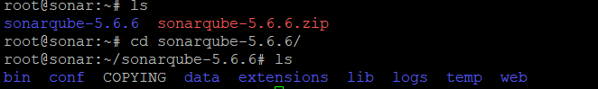

Now install mysql server

Apt-get install mysql-server -y

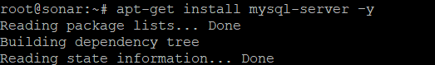

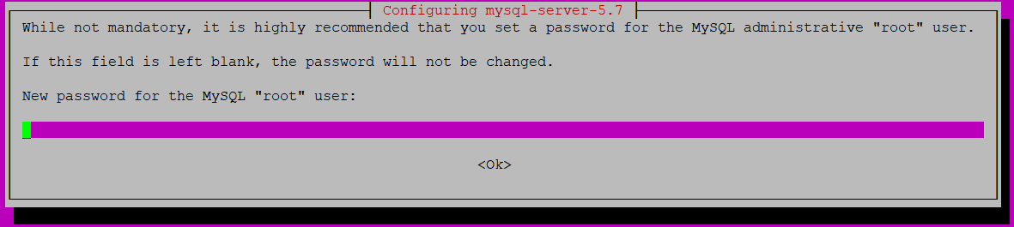

Here give any password.i will give 123456

Reenter password

Now connect to mysql database

Username is root

Password is 123456

Now type 🡪mysql –u root –p

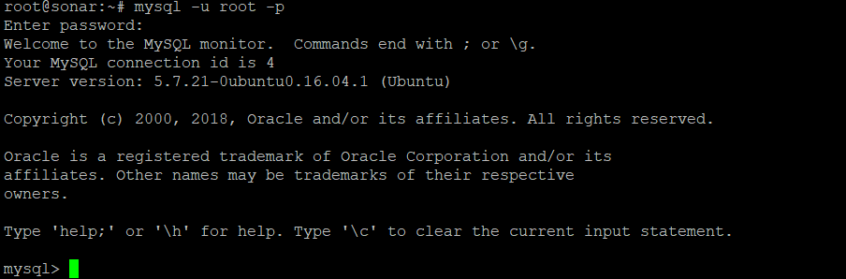

In sql prompt please enter the following and press enter

CREATE DATABASE sonar CHARACTER SET utf8 COLLATE utf8_general_ci;



In sql prompt now type the following and press enter

CREATE USER 'sonar' IDENTIFIED BY 'sonar';

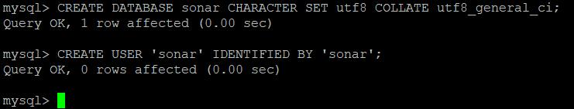

Now in sql type and press enter

GRANT ALL ON sonar.* TO 'sonar'@'%' IDENTIFIED BY 'sonar';



Now in sql type and press enter

GRANT ALL ON sonar.* TO 'sonar'@'localhost' IDENTIFIED BY 'sonar';

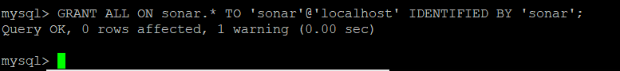

Now in sql type and press enter

FLUSH PRIVILEGES;

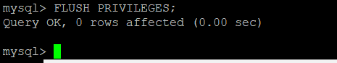

Now come out of mysql by typing exit

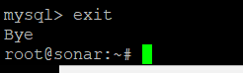

Now in root directory we downloaded sonarzipfile,move to that folder.

Inside that folder move to conf directory

There will be a file by name sonar.properties

Open sonar.properties file by using vi

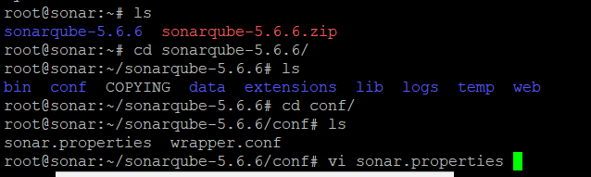

Uncomment

Sonar.jdbc.username=sonar

Sonar.jdbc.password=sonar

Uncomment ---sonar.jdbc.url=jdbc:mysql://localhost

Just follow below pic

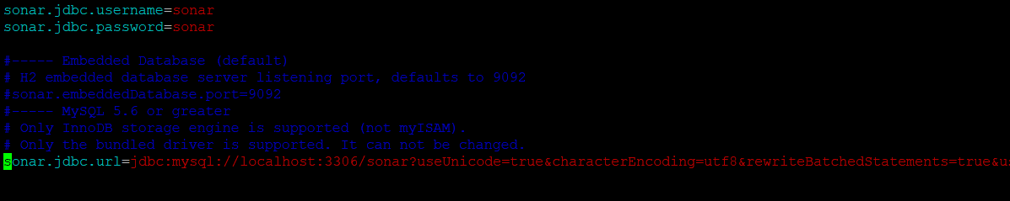

Save and exit

Now go to bin directory of sonarcube ,

inside bin move to linux-x86-64

inside linux-x86-64 there is a file by name sonar.sh

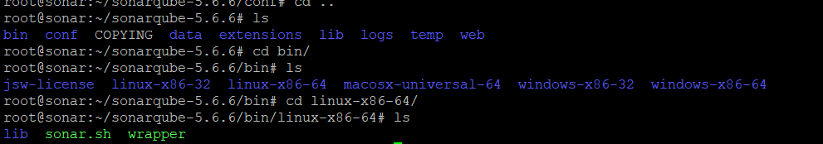

Now start the sonar service by typing sh sonar.sh start

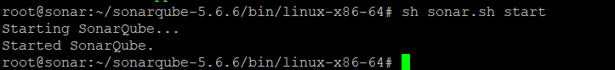

Stop the fire walls by typing service ufw stop



Now in security group please open the ports 9000,3306

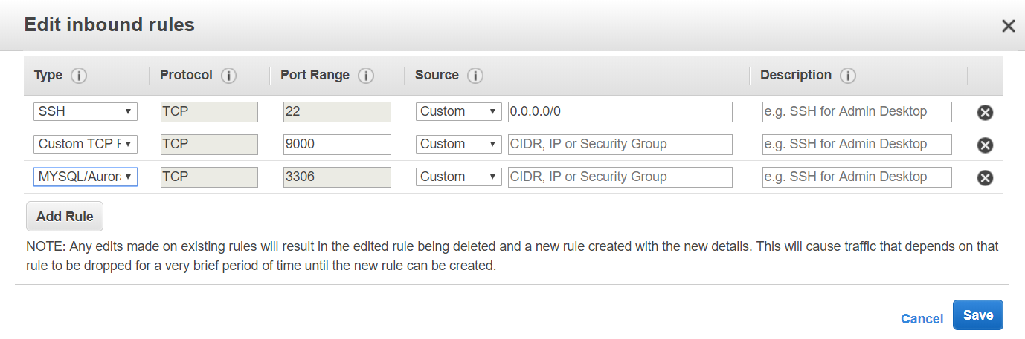

Take the public ip of sonarqube and paste it in browser like this .

In my case 54.146.235.255**:9000**

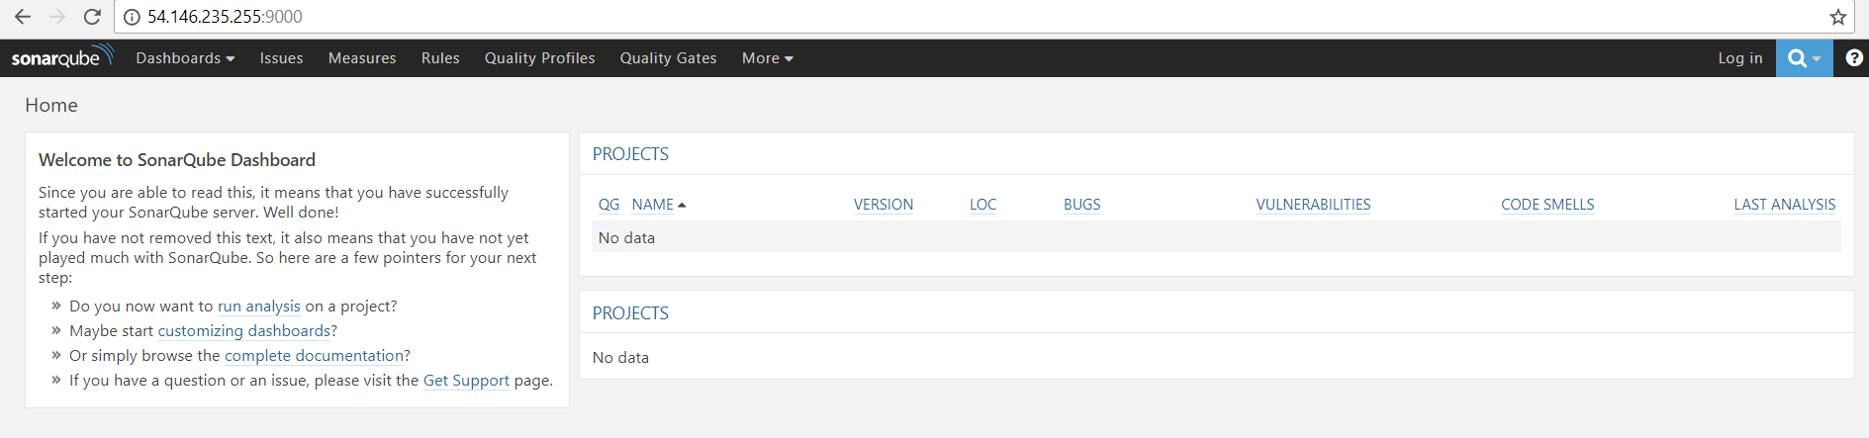

now log in into sonarqube

Default username is 🡪admin

Password is🡪 admin

After login goto->administration->my account

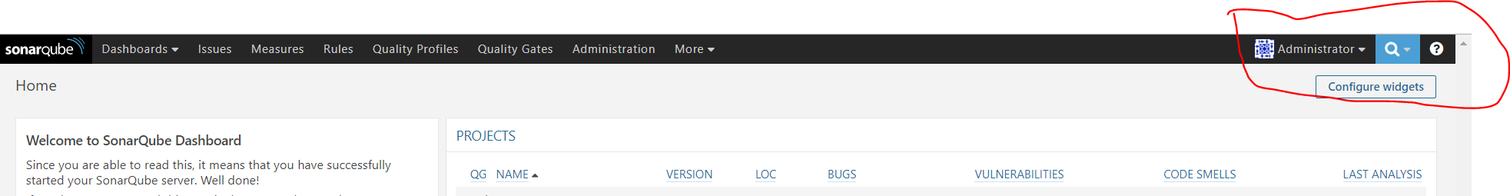

generating the token for futher use

goto 🡪security

give any name 🡪Genereator tokens🡪Enter token name

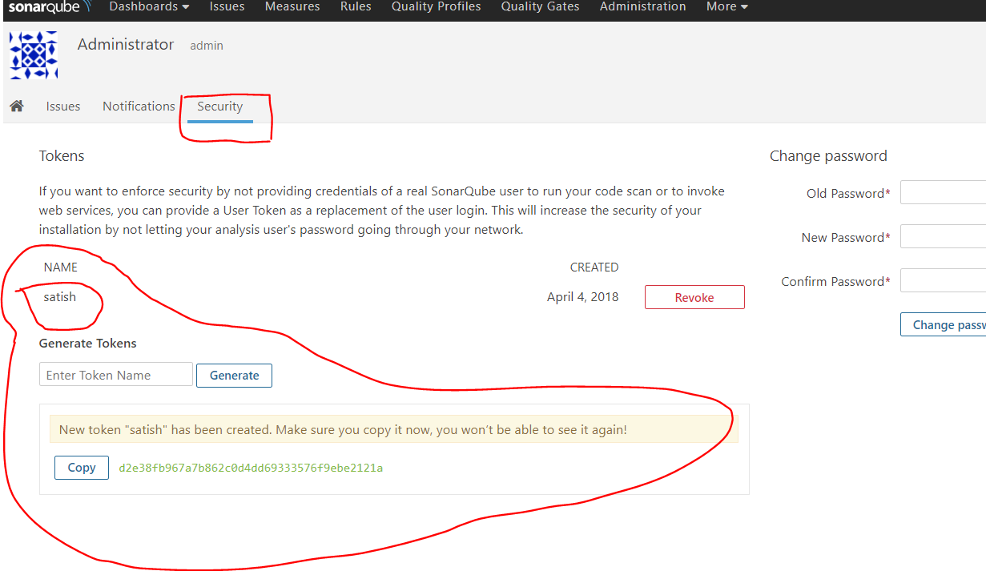

Now take another instance

Install java,git,maven,Jenkins

Create one maven job

Install sonarqube plugin

Go to Jenkins Manage🡪configure system just follow below pic

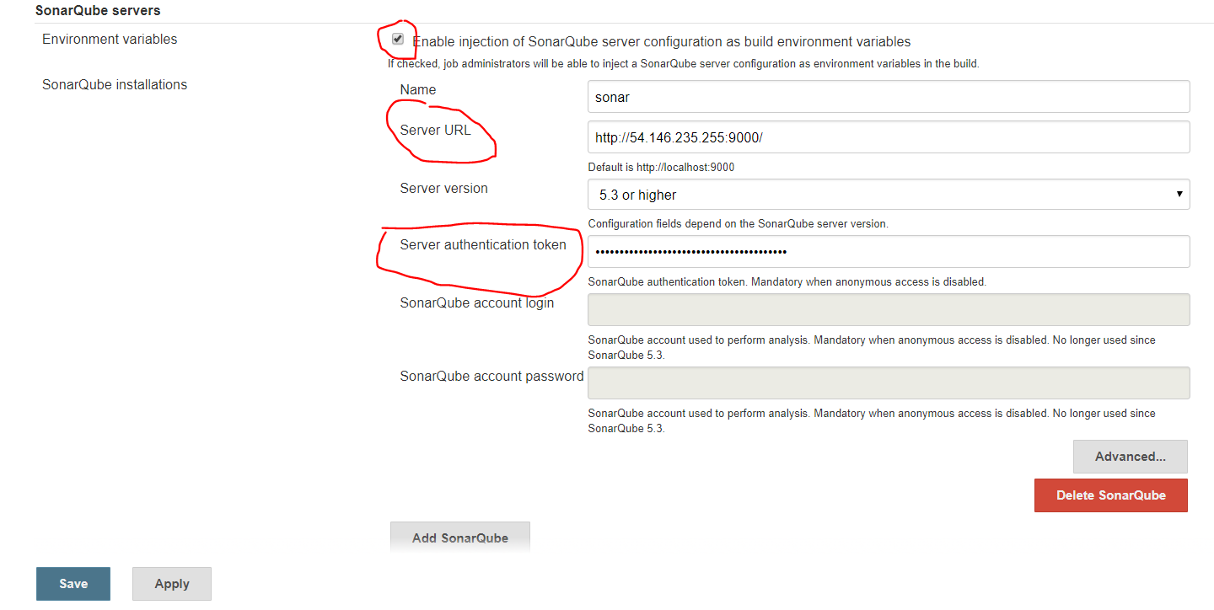

Now goto->global tool configuration as below

Now goto Global tool configuration ..follow below pic

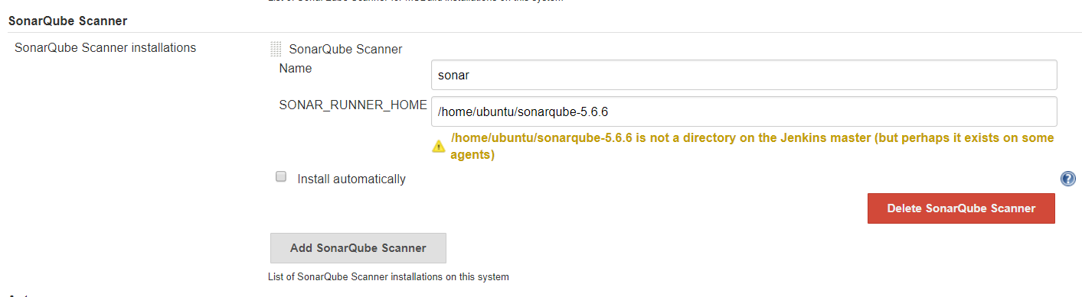

Now create new job(Helloworld)

I’m taking maven job, automatically comes here, if it is not come refresh server once

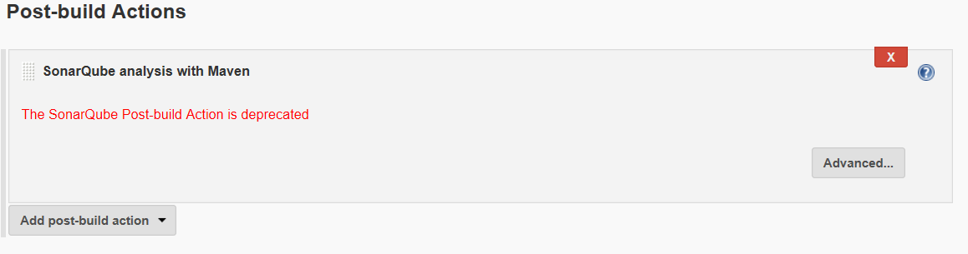

Save & apply

Now build the project

Just check console output..follow below pic

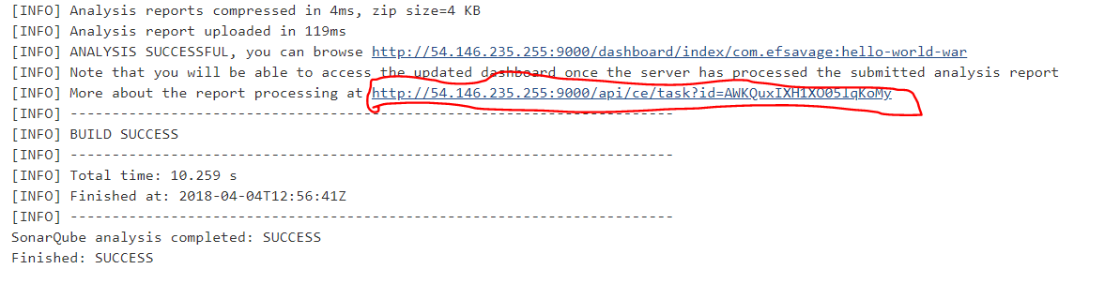

Now go to sonarqube Dashboard🡪home

Check

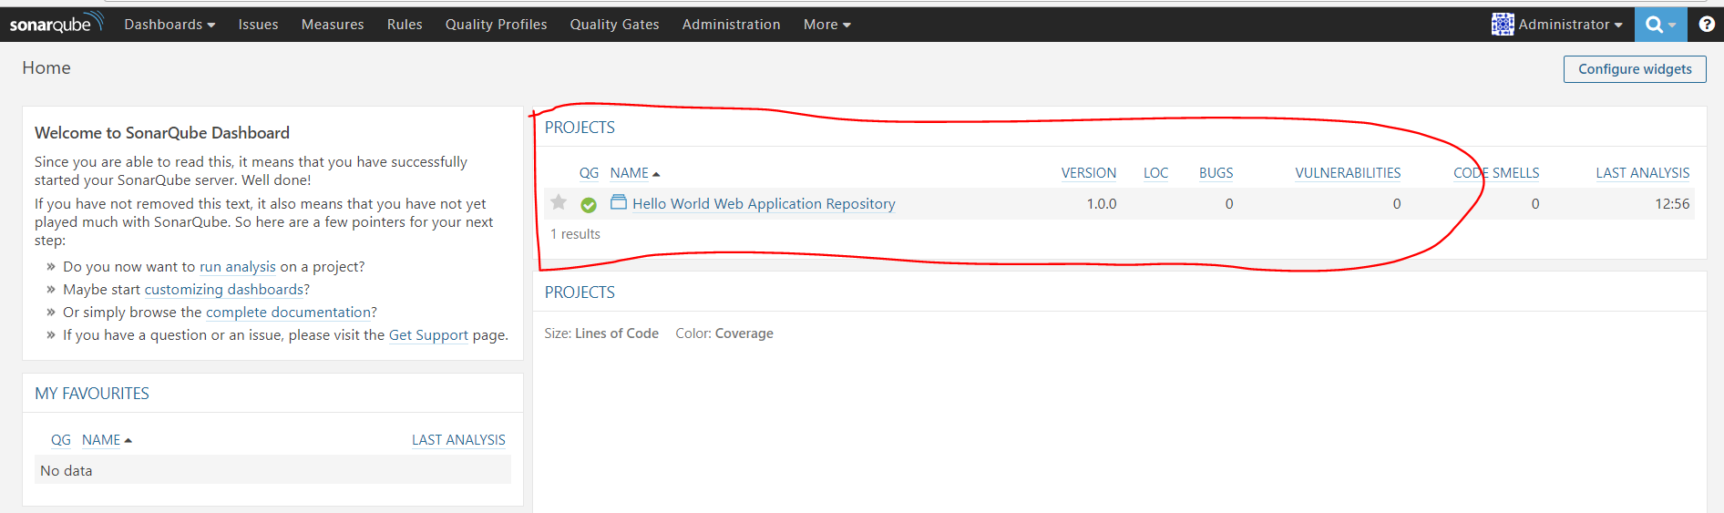

This is status of your code appear here..

